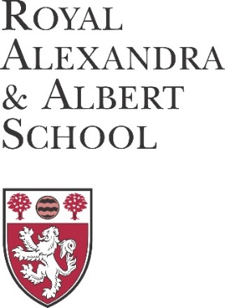
APPLICATION FOR A MUSIC
OR SPORTS SCHOLARSHIP

1. I am applying for a Sports Scholarship

Music Scholarship

2. My child is currently a pupil at the Royal Alexandra and Albert School
No |  | Please complete Section A overleaf
Yes |  | Please complete Section B overleaf

Once completed, please return this form, together with references and a Music or Sports CV, to Admissions, Royal Alexandra and Albert School, Gatton Park, Reigate, Surrey, RH2 0TD. Alternatively, this form and supporting documentation can be emailed to admissions@gatton-park.org.uk. Further details, including application deadlines, can be found on www.raa-school.co.uk/scholarships.asp.

SECTION A – NEW APPLICANTS
Applicants for a scholarship must have completed a Boarding or Non Boarding application, or be current pupils at the school. If you have not completed an application to the School, please go to the school website (www.raa-school.co.uk) and complete an application.

Child’s surname |  | Parent surname
Child’s first name |  | Parent first name
Child’s gender | Boy / Girl  delete as applicable | Parent salutation | Mr/Mrs/Miss/Ms/ Other ___________
Date of birth |  | Contact phone no.
Contact email
Current year group |  | Proposed start date

SECTION B – CURRENT PUPILS
Child’s surname |  | Parent surname
Child’s first name |  | Parent first name
Contact phone no. |  | Parent salutation | Mr/Mrs/Miss/Ms/ Other ___________
Contact email

