
School Office: 01737 649000

Weekly Newsletter

Issue No.7– 2013/2014

18th October 2013

The following items can be found within this week’s Newsletter:

Whole School
PTA Shopping Event (Page 2)
Match Funding (Page 3)
Drama Department News (Page 4)
School Photos (Page 4)
Remember – Reflect (Page 4)
Chaplain’s 400 (Page 5)
Music Department News (Page 5)
Boarder Trips (Page 5)
Stables News (Page 6)
Junior School
Golden Book (Page 7)
Angels & Top Men (Page 8)
Stranger Danger (Page 8)
Junior Archery & Climbing (Page 8)
Senior School
Calculators (Page 9)
Kent House go to Fright Night (Page 9)
Parental Consultation (Page 9)
Sports Results (Pages 10 & 11)

THOUGHT FOR THE WEEK

“A small decision now can change all your tomorrows”

Robert Schuller



WHOLE SCHOOL

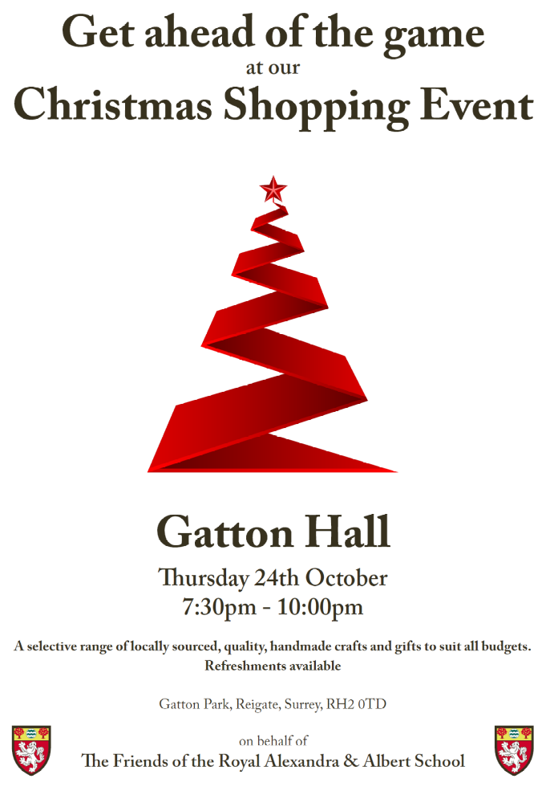



Calling all parents?

Does your company offer Match Funding?

The Friends of RAAS raise around £10k every year for the pupils of RAAS.

Imagine if this was matched by your company?

This would be £20k for your children’s benefit.

If your company offers Match Funding, we would love to hear from you.

Please contact PTAfriends@gatton-park.org.uk
Drama Department News

Alice 13:

Rehearsals are well underway for the end of term show. Now we are recruiting willing volunteers to help create costumes and props. If you are willing & able, please email Mrs Love and she will allocate you a task.

LAMDA Coaching:

We offer small group lessons with a professional coach, working towards graded Speech & Drama exams. These sessions are extremely useful for developing young people’s physical and vocal communication skills, as well as offering focused development of performance skills. At the higher levels, LAMDA awards carry UCAS points.

For further details please email Mrs Love – emmalove@gatton-park.org.uk

Emma Love
Head of Drama

School Photos

House, Individual and Sibling photos are being given to the pupils today. Any orders must be returned to the school by Monday 11th November at the absolute latest. You will need to pay for the postage if photos are not returned by this date.

Reminder: Remember - Reflect Service
12.30pm Saturday 19th October 2013

St. Andrew’s Church
Pupils, friends and family are very welcome to join us for a short time of reflection to remember special people we have known who have died.

Chaplain’s 400

If you peeked in my diary, you would find a suspiciously large number of anniversaries. Only a few names are birthdays. You would find my father’s name, his parents, some from RAAS, and many careless enough to have been my friends. The names reveal many countries and cities. All are dead people. They also include notable leaders of religious and political life since 2500 BCE, a few saints, and some taken randomly from news clips, like an Australian thirteen year old who gave away his life in an instant to save his mother and younger brother from a raging Australian flood. Why maintain these snippets of information? Is this morbid preoccupation with matters better put out of mind? I think not.

At assemblies this week, I pointed to the weeks immediately before us as a time in which Western thoughts turn to those ‘whom we have loved but see no longer’. On Saturday, we have ‘Remember Reflect’ at School, in which individuals sit in community to honour key people and experiences. On November 1st, All Saints Day is followed by All Souls Day. On Monday 11 November, the day after a much needed break, Remembrance Day, when too many people all over the world recall millions of young lives cut off when the human race failed itself in a thousand places.

The word religion is based on the Latin word ‘religion’ – ‘I tie myself back’. Whether it is a Catholic requiem mass, a Reformed Church memorial service, or the Buddhist Festival of the Hungry Ghosts, our ceremonies, prayers and songs do more than comfort the living in the face of death. They preserve the good achieved by the departed. They remind the living that being alive is not a permanent condition. At their best, ceremonies evoke community across the divide which separates the living from the departed – hence the names in my diary. I believe that most critics who find these spiritual practices unreal and sentimental are themselves foolish and trivial. Their comments mostly betray total ignorance of the ideas behind them, and above all, ignorance of the fact that sentimental comfort is the last thing to which ceremonies direct us. True religion at these moments ties us back to what is deepest and most valuable. It is a paradox that we become fully alive only as we grasp the nature of the opposite condition. Seasons and times of remembrance are invitation to do this, and to do it well, for our sake, and for all around us.

Music Department News

The music activities timetable is changing after the half term holiday. Please email alisonbutler@gatton-park.org.uk for further information.
Alison Butler
Director of Music

Boarder Trips

Extra Spaces –

21st November Nutcracker Ballet (Open to Boarders and Flexi Boarders)

1st December Coral Reef (December) (Open to Boarders and Flexi Boarders)

17th January The Circus of Horrors (Open to Boarders and Flexi Boarders)

New –

22nd October Cosmo (Open to all Sixth Form)

13th November Sandown Skiing (For those new to skiing)

17th November Camden Market (Year 11-13)

20th November Sandown Skiing (Controlled Snow Plough)

23rd November Rugby League (All Senior School)

Stables News

Last Sunday 13th October the Surrey British Horse Society held a Dressage competition at the Stables. This competition was the perfect opportunity for several of our pupils of all ages and abilities to compete. It was a brilliant experience for our pupils. On Saturday 12th October pupils came to the Stables after Saturday school to experience competition preparation which involved collecting their horses from the field, grooming, plaiting and tack cleaning. You prepare for shows the day before so that you are not rushing on the morning of the show.
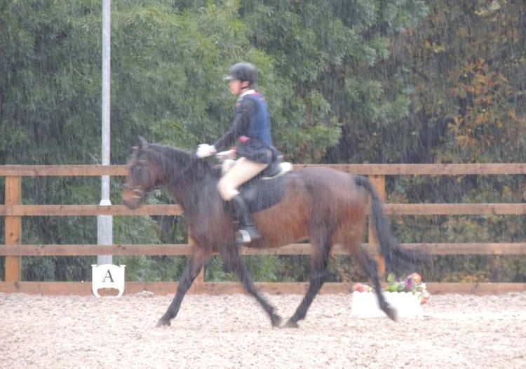
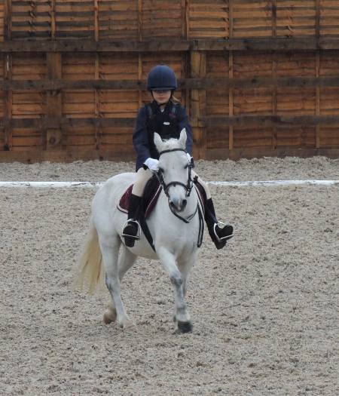
On the day of the competition everyone woke up, looked out of their windows and gasped at the awful weather as it was tipping down. But this did not stop anyone, all of our dedicated pupils came down to the yard in their messy clothes (we didn’t want to get light coloured shirts and jodhpurs dirty before they had to!), groomed, rolled their horses plaits and tacked their horses up ready to go into the warm up ring before their test. Congratulations to all of our pupils for their hard work, effort and dedication in both preparing for the competition and on the day. All pupils rode extremely well despite the weather (this competition was a 1st for many) and several people commented on how well turned out our pupils and horses were on the day.
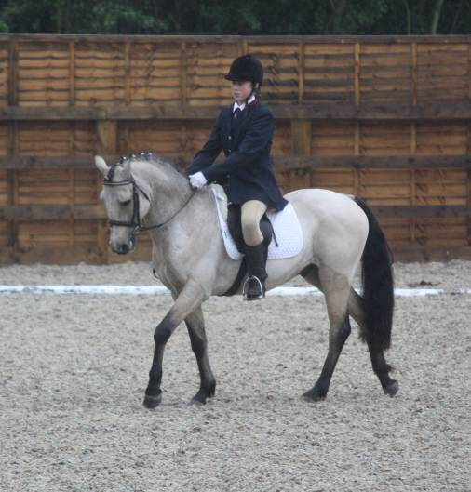
Don’t forget that the Stables have their very own Halloween Show Jumping Competition for current riding pupils next Wednesday 23rd October – the competition is being run under the British Show Jumping Rules so that we can give every pupil the opportunity to experience a Jumping Competition. There are still spaces for the competition but they are filling fast. If your child would like to take part in the above competition then please email the stables on stables@gatton-park.org.uk for an entry form. There are rosettes to 6th place with special and clear round rosettes for those that complete class 1 or 3’s course clear without any faults. We look forward to seeing you all there.

JUNIOR SCHOOL

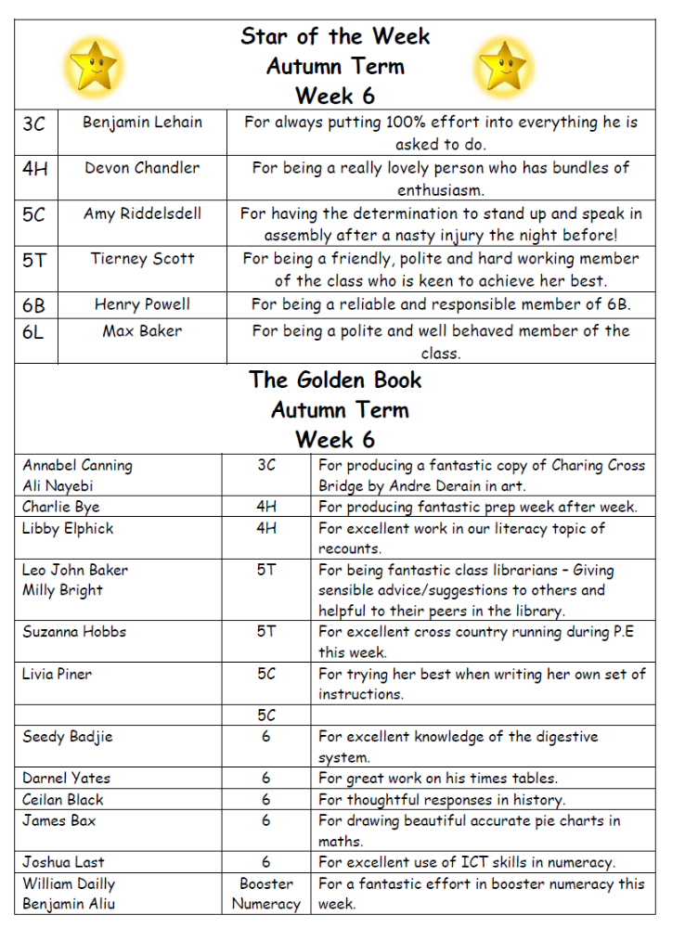


Angels of the Week:

Daniella Hince

Ruby Jahnke

Top Men of the Week:

Devon Chandler
James Dorrell

Well done to all
Mr Stafford
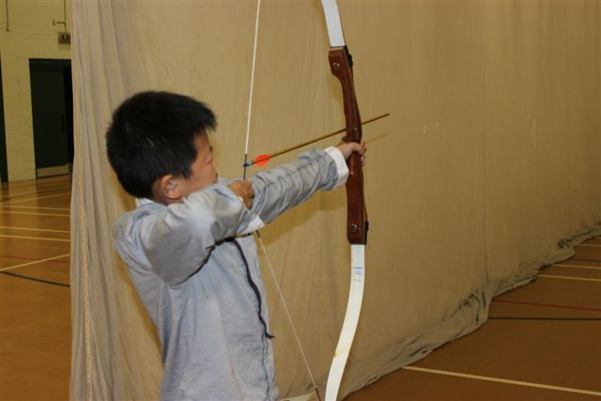
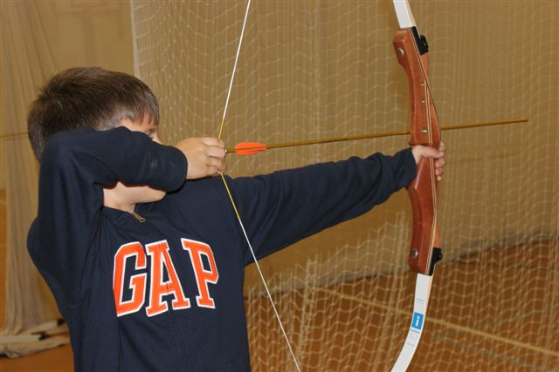
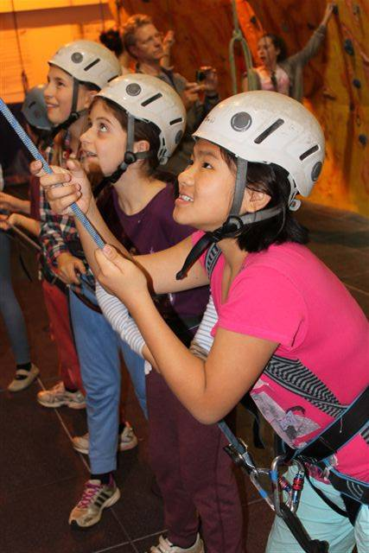
Head of House
At House Assembly this week we saw the entries from Mrs Stafford’s “Stranger Danger” poster competition. There were prizes for runners up and the winners.

The posters can be seen on display in the Junior School and Rank Weston.
Junior Archery and Climbing

SENIOR SCHOOL
Calculators

The Mathematics Department would like to ensure that all students own their own scientific calculator. We are currently selling new calculators (Blue, Pink or Grey) that can be ordered through Mrs Glover at a cost of £7 each.

We will also be selling second hand calculators every break time in Maths room 4, all of next week. These are calculators previously used in the department, and will be sold for £2 each. Any queries please contact Mrs Glove – emmaglover@gatton-park.org.uk

Kent House go to Fright Night at Thorpe Park

On Saturday, Kent House made its annual trip to Thorpe Park to enjoy the roller-coasters at night and the various additional mazes that they put up for Fright Night. 54 boys in total went after school and then returned when the park closed at 10pm. It was a brilliant day and most of us enjoyed the unlimited pizza and drinks in Pizza Hut. Mr Dyson without doubt holds the record for the most pizza eaten though he was too scared to go on Detonator. We will have to do it again next year!

Mr Rowe
Head of Kent House

Year 7 and Year 10 Parental Consultation Evenings

Day Boarders/Day Pupils: Wednesday 23 October 17.00 – 20.00
Boarders: Friday 25 October 16.00 – 18.00

Please be advised that we have Parental Consultation Evenings next week for pupils in Year 7, Year 10 and any new pupils in Years 8 & 9 who joined September 2013.

Meetings with teachers/form tutors are by appointment only. Invitation letters have been sent out to all Year 7 and Year 10 parents/guardians, along with guidelines, which will ensure appointments are made quickly and efficiently for you. They will have the opportunity to meet with their child’s class tutor and up to 7 individual subject teachers. In addition an appointment can be requested with Mr Pawson, Head of Sixth Form.

Mr Spencer Ellis, other members of the senior leadership team and Heads of Year will also be present and available on both evenings.

Kathryn Hobbs
Deputy Head
Director of Studies

SENIOR SCHOOL SPORTS RESULTS

 NETBALL

FIXTURE | RESULT | MAN of the MATCH
District League

Year 7 | RAAS 2 Oakwood 3 | Layah Garside
Year 8 | RAAS 18 Oakwood 0 | Angharad Wise
Year 9 | RAAS 18 LND 9 | Macey Wallace
Year 10 | RAAS 11 LND 9 | Lucy Hoad
Friendlies
Year 7’A | RAAS 6 Dunottar 7 | Molly Cameron
Year 7’B’ | RAAS 8 Dunottar 3 | Hannah Dees
Year 8 | RAAS 10 Dunottar 8 | Selina Aydin
Year 9 | RAAS 14 Dunottar 1 | Annie Crawley


FOOTBALL

FIXTURE | RESULT | MAN of the MATCH
Surrey Schools Cup
Round 1
Year 9 | Bishop Wand conceded game to RAAS
1st X1 | RAAS 1 Hampton School 3 | Damani Francis


HOCKEY

FIXTURE | RESULT | MAN of the MATCH
Year 8 | RAAS 0 Greenacre 4
Year 9 | RAAS 0 LND 2



RUGBY

FIXTURE | RESULT | MAN of the MATCH
Friendlies
vs Emanuel
1stXV | RAAS 17 Emanuel 32
Year 10 | RAAS 57 Emanuel 29 | Nissan Chungbang
Year 9 | RAAS 0 Emanuel 20 | Angus Calder: Zia Inneriaty
Year 8 | RAAS 0 Emanuel 60
Year 7 | RAAS 7 Emanuel 21 | Silver Francoise
vs Oxted
Year 7 | RAAS 26 Oxted 7 | Kyran Bostel
Year 8 | RAAS 19 Oxted 54
vs St Bedes
Year 9 | RAAS 45 St Bedes 10
vs Warlingham
Year 7 | RAAS 49 Warlingham 0 | Kieran Green
Year 8 | RAAS 60 Warlingham 19
Year 9 | RAAS 47 Warlingham 10 | Joint: Angus Calder  Corin Becksmith
NAT WEST VASE 1stXV
vs Richard Challoner | R RAAS 27 Richard Challoner 20

